SOFTWARE CHANGE
IMPLEMENTATION REPORT

CR-001: Client-Side Search and Filtering of the Admin Student List

Field | Details
Change Request ID | CR-004
Change Request Title | Student Input Field Validation for Add and Edit Operations
Student Name | M M Amal
Student ID | JF/ICT/24/15
Implementation Status | Completed
Date | 8 October 2026

Change Request Summary

Business Requirement
The student management system required improved validation for student information entered through the administrator Add and Edit student operations.
The change was required to ensure that student information is complete, correctly formatted, and suitable for storage. The validation must improve data quality and prevent invalid or insecure student information from being submitted.
The validation requirements include valid registration numbers, valid first and last names, valid email addresses, exactly 10 numeric digits for phone numbers, and strong passwords when creating a student account.
Both client-side and server-side validation are required so that invalid data is prevented at the user interface and cannot be submitted directly to the backend to bypass frontend validation.

Existing Behaviour
Before implementation:

    - The administrator could add and edit student records through the existing student form.
    - Basic required-field validation was available.
    - First and last names did not comprehensively enforce minimum length and valid character requirements.
    - Phone numbers were not comprehensively restricted to exactly 10 numeric digits.
    - Email validation was not sufficiently comprehensive.
    - Registration number validation was not comprehensive.
    - Password validation did not comprehensively enforce strong password requirements for new student accounts.
    - Invalid data could potentially be submitted directly to the backend without comprehensive server-side validation.

Requested Change

Comprehensive input validation was required for the administrator Add and Edit student operations.
The validation must:
- Validate all required student fields.
- Validate the student registration number.
- Require first and last names to contain at least 3 characters.
- Allow only valid alphabetic characters in first and last names.
- Reject inappropriate numbers and special characters in name fields.
- Validate the email address format.
- Require the phone number to contain exactly 10 numeric digits.
- Reject phone numbers containing fewer or more than 10 digits.
- Reject non-numeric characters in the phone number.
- Require a password when creating a new student.
- Require passwords to contain at least 8 characters.
- Require at least one uppercase letter.
- Require at least one lowercase letter.
- Require at least one number.
- Require at least one special character.
- Display clear validation error messages to the administrator.
- Prevent invalid data from being submitted through the frontend.
- Apply server-side validation to prevent frontend validation from being bypassed.
- Preserve the existing Add, Edit, Delete, authentication, authorization, database, and password-hashing functionality.

Implementation

Implementation Summary
The CR-004 requirements were implemented by adding comprehensive client-side and server-side validation to the existing student Add and Edit functionality.
Client-side validation was implemented in StudentFormModal.jsx. The form now checks student input before an API request is submitted. Validation errors are displayed to the administrator and invalid form submissions are prevented.
Server-side validation was implemented in studentController.js. The backend validates incoming student data before allowing the existing create or update operation to continue. This prevents invalid data from being stored even if frontend validation is bypassed.
The implementation does not introduce a new API endpoint or database schema change. Existing Add, Edit, Delete, authentication, authorization, and password-hashing functionality are preserved.

Affected Files

File | Change | Purpose
 | Modified | Added comprehensive client-side validation for student Add/Edit input, error handling, and invalid-submission prevention
  frontend/src/components/StudentFormModal.jsx
backend/src/controllers/studentController.js | Modified | Added server-side validation to reject invalid student data before database operations
Additional files | None | No additional application files were required for the core CR-004 validation implementation

Technical Changes

Client-Side Validation

The student form was updated to validate user input before submitting data to the backend.
The validation checks include:
- Required-field validation.
- Registration number validation.
- First-name validation.
- Last-name validation.
- Email validation.
- Phone-number validation.
- Password validation for student creation.
- Clear field-level validation messages.
- Prevention of invalid form submission.

The validation result is stored and displayed through the existing form error handling.

First Name and Last Name Validation

The first name and last name fields were updated to enforce the CR-004 requirements.
The validation checks:
- The field must not be empty.
- The name must contain at least 3 characters.
- The name must contain valid alphabetic characters.
- Numbers are rejected.
- Inappropriate special characters are rejected.

For example:
Jo
is rejected because it contains fewer than 3 characters.

John
is accepted as a valid name.

A value containing numbers or inappropriate special characters is rejected.

Email Validation

The email field was updated to validate the entered email address.
The validation prevents obviously invalid email formats from being submitted and provides a clear validation message when the entered value is not valid.
A valid email format is accepted and can proceed to the backend.

Phone Number Validation

Phone number validation was implemented to enforce exactly 10 numeric digits.
The validation rejects:
- Fewer than 10 digits.
- More than 10 digits.
- Alphabetic characters.
- Other non-numeric characters.
Only a phone number containing exactly 10 numeric digits is accepted.

Password Validation

Password validation was strengthened for new student creation.
The password must:
- Be provided when creating a new student.
- Contain at least 8 characters.
- Contain at least one uppercase letter.
- Contain at least one lowercase letter.
- Contain at least one number.
- Contain at least one special character.
A password that does not satisfy all required conditions is rejected and the administrator is shown an appropriate validation message.

Registration Number Validation

The registration number field was included in the validation process to ensure that an invalid registration number is not submitted through the student form.
The validation occurs before the create or update request is sent to the backend.

Error Handling

Clear validation errors are displayed when invalid input is entered.
The administrator can identify the field requiring correction and update the value before attempting submission again.
When validation succeeds, the form can continue with the existing Add or Edit operation.

Server-Side Validation

Server-side validation was added to studentController.js.
The backend validates incoming student information before continuing with the existing database operation.
This provides an additional security layer because client-side validation can potentially be bypassed by sending a direct API request.
The backend therefore checks the important validation requirements independently of the frontend.

Server-Side Name Validation

The backend validates first and last names for:
- Required values.
- Minimum length.
- Valid characters.
Invalid name values are rejected before the student record is created or updated.

Server-Side Email Validation

The backend validates the email value received from the API request before allowing the student operation to continue.
Invalid email input is rejected by the server.

Server-Side Phone Validation

The backend validates that the phone number:
- Contains only numeric digits.
- Contains exactly 10 digits.
Requests containing invalid phone numbers are rejected before database storage.

Server-Side Password Validation

For student creation, the backend validates that the password:
- Is provided.
- Contains at least 8 characters.
- Contains an uppercase letter.
- Contains a lowercase letter.
- Contains a number.
- Contains a special character.
This prevents a user from bypassing the frontend and submitting a weak password directly through the API.

Existing Password Security

The existing password hashing process is preserved.
The CR-004 implementation adds validation before the existing password storage process and does not replace the existing password hashing mechanism.

Existing CRUD Preservation

The existing student CRUD operations were preserved.
The validation layer only determines whether the submitted student data is valid.
Valid data continues through the existing Add or Edit process.
The existing Delete functionality is not changed by the validation implementation.

Implementation Logic

The implementation follows the following process:
- The administrator opens the student Add or Edit form.
- The administrator enters student information.
- The frontend collects the entered values.
- Client-side validation checks the required fields.
- Registration number validation is performed.
- First and last names are checked for minimum length and valid characters.
- Email format is validated.
- Phone number is checked for exactly 10 numeric digits.
- Password requirements are checked when creating a student.
- If validation errors exist, the errors are displayed and the API request is prevented.
- If all client-side validation checks pass, the existing API request is submitted.
- The backend receives the request.
- Server-side validation is performed again.
- If invalid data is received, the backend rejects the request.
- If the data is valid, the existing Add or Edit operation continues.
- The existing database operation is performed.
- Existing authentication, authorization, CRUD, and password-hashing behaviour remains unchanged.

Error and Data Handling
The implementation prevents invalid form data from being submitted through the frontend.
Validation errors are displayed to the administrator so that incorrect fields can be corrected.
The backend also validates incoming data independently. Therefore, invalid requests sent directly to the API do not bypass the validation requirements.
Valid student information continues through the existing create or update process.
The implementation does not change the existing database schema or introduce a new validation API.

Testing & Verification

Testing Approach
The CR-004 implementation was verified through manual testing of the administrator student Add and Edit functionality.
Testing covered the validation requirements defined for the change request as well as regression testing of the existing student CRUD functionality.

Testing Types:

    - Functional testing
    - Positive testing
    - Negative testing
    - Input validation testing
    - Client-side validation testing
    - Server-side validation testing
    - UI validation testing
    - Error-message testing
    - Security validation testing
    - CRUD regression testing

Environment: Development Browser: Chrome
Test Role: Administrator

Test Cases

Test ID | Test Case | Expected Result | Actual Result | Status
TC-01 | Submit the Add Student form with required fields empty | Required-field validation messages are displayed and submission is prevented | Required-field validation was displayed and submission was prevented | Pass
TC-02 | Enter a first name with fewer than 3 characters | First-name validation error is displayed | Invalid short name was rejected | Pass
TC-03 | Enter a last name with fewer than 3 characters | Last-name validation error is displayed | Invalid short name was rejected | Pass
TC-04 | Enter numbers or inappropriate special characters in a name field | Name validation error is displayed | Invalid characters were rejected | Pass
TC-05 | Enter an invalid email address | Email validation error is displayed and submission is prevented | Invalid email was rejected | Pass
TC-06 | Enter a phone number containing fewer than 10 digits | Phone validation error is displayed | Short phone number was rejected | Pass
TC-07 | Enter a phone number containing more than 10 digits | Phone validation error is displayed | Long phone number was rejected | Pass
TC-08 | Enter non-numeric characters in the phone field | Phone validation error is displayed | Non-numeric phone input was rejected | Pass
TC-09 | Enter a valid 10-digit phone number | Phone number is accepted | Valid phone number was accepted | Pass
TC-10 | Create a student without a password | Password-required validation is displayed | Submission was prevented | Pass
TC-11 | Enter a password shorter than 8 characters | Password validation error is displayed | Weak password was rejected | Pass
TC-12 | Enter a password without an uppercase letter | Password validation error is displayed | Password was rejected | Pass
TC-13 | Enter a password without a lowercase letter | Password validation error is displayed | Password was rejected | Pass
TC-14 | Enter a password without a number | Password validation error is displayed | Password was rejected | Pass
TC-15 | Enter a password without a special character | Password validation error is displayed | Password was rejected | Pass
TC-16 | Enter a password satisfying all strength requirements | Password is accepted | Strong password was accepted | Pass
TC-17 | Add a student using valid information | Student is created successfully | Student was created successfully | Pass
TC-18 | Edit an existing student using valid information | Student is updated successfully | Student was updated successfully | Pass
TC-19 | Submit invalid student data directly to the backend/API | Backend rejects the invalid request | Invalid request was rejected by server-side validation | Pass
TC-20 | Edit a student and verify the existing student record is updated | Correct student record is updated | Correct student record was updated | Pass
TC-21 | Delete an existing student after validation changes | Existing Delete functionality continues to work | Delete functionality continued to work | Pass
TC-22 | Verify administrator authentication and authorization after implementation | Existing access control continues to work | Existing authorization behaviour remained unchanged | Pass

Test Summary

Test Result | Count
Total Test Cases | 22
Passed | 22
Failed | 0
Pass Rate | 100%
Overall Test Result: Pass
The validation implementation successfully handled the tested valid and invalid input scenarios while preserving the existing student management functionality.

Acceptance Criteria Verification

ID | Acceptance Criterion | Verification | Status
AC-001 | Required student fields cannot be submitted empty | Required-field validation test | Met
AC-002 | First name must contain at least 3 characters | Short first-name test | Met
AC-003 | Last name must contain at least 3 characters | Short last-name test | Met
AC-004 | First and last names must contain valid characters | Invalid name-character test | Met
AC-005 | Email address must use a valid format | Invalid email test | Met
AC-006 | Phone number must contain exactly 10 digits | Valid and invalid phone tests | Met
AC-007 | Phone numbers with fewer than 10 digits are rejected | Short phone-number test | Met
AC-008 | Phone numbers with more than 10 digits are rejected | Long phone-number test | Met
AC-009 | Non-numeric phone values are rejected | Non-numeric phone test | Met
AC-010 | A password is required when creating a student | Empty-password test | Met
AC-011 | Password must contain at least 8 characters | Short-password test | Met
AC-012 | Password must contain an uppercase letter | Password-strength test | Met
AC-013 | Password must contain a lowercase letter | Password-strength test | Met
AC-014 | Password must contain a number | Password-strength test | Met
AC-015 | Password must contain a special character | Password-strength test | Met
AC-016 | Valid student data can be used to create and update a student | Valid Add/Edit testing | Met
AC-017 | Invalid data submitted directly to the backend is rejected | Direct API/server-side validation test | Met
AC-018 | Existing Edit, Delete, authentication, authorization, and password security remain functional | Regression testing | Met

Evidence

Evidence 01 – Client-Side Validation
Description: Administrator student Add/Edit form displaying validation errors for invalid student input.
Related: AC-001, AC-002, AC-003, AC-005, AC-006, AC-010, AC-011, AC-012, AC-013, AC-014, AC-015
Evidence:
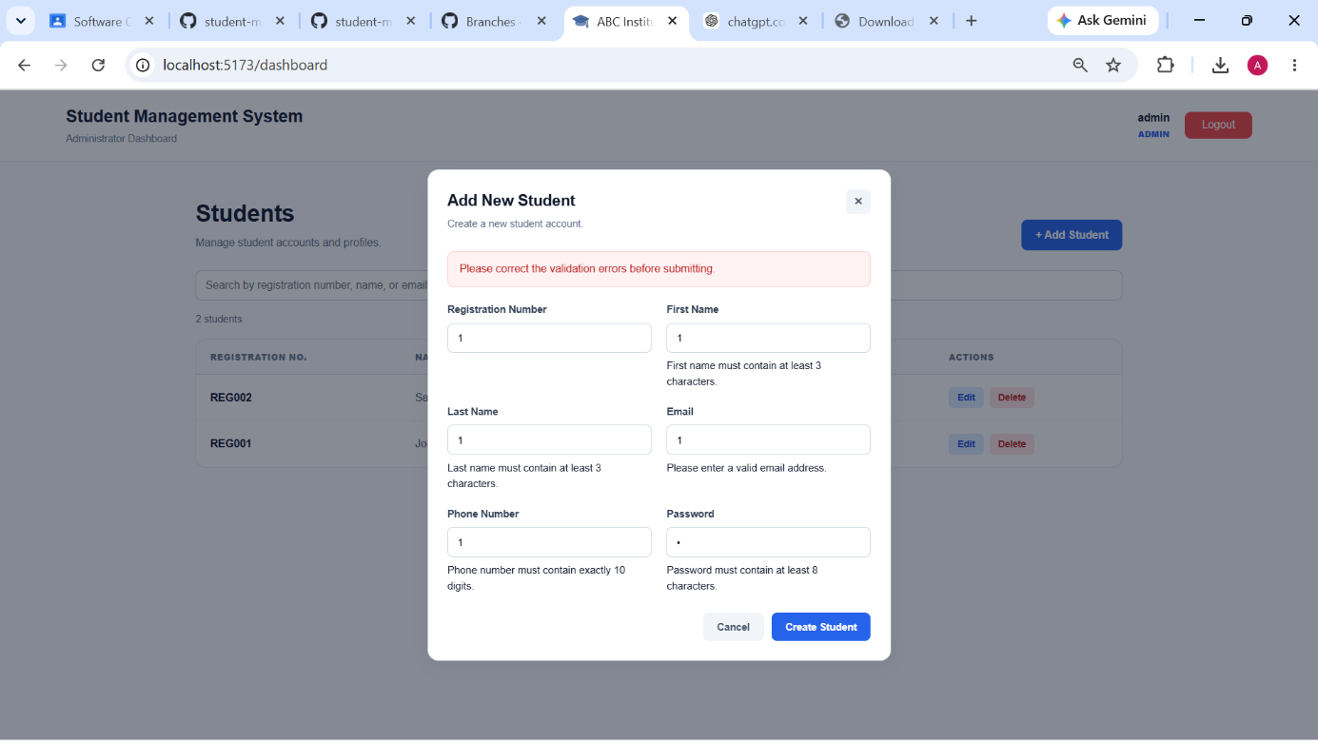
Figure 1 Administrator student form showing client-side validation errors for invalid input.

Evidence 02 – Valid Submission / Backend Validation
Description: Verification of successful valid student Add/Edit operation and/or server-side rejection of invalid API data.
Related: AC-016, AC-017, AC-018
Evidence:

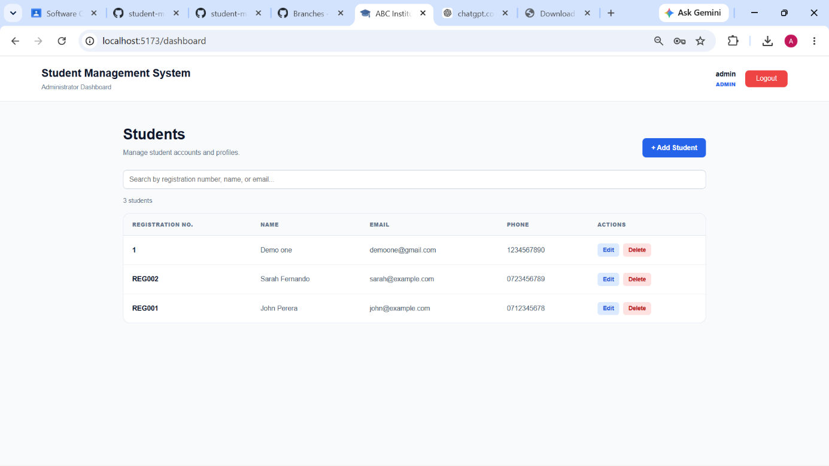

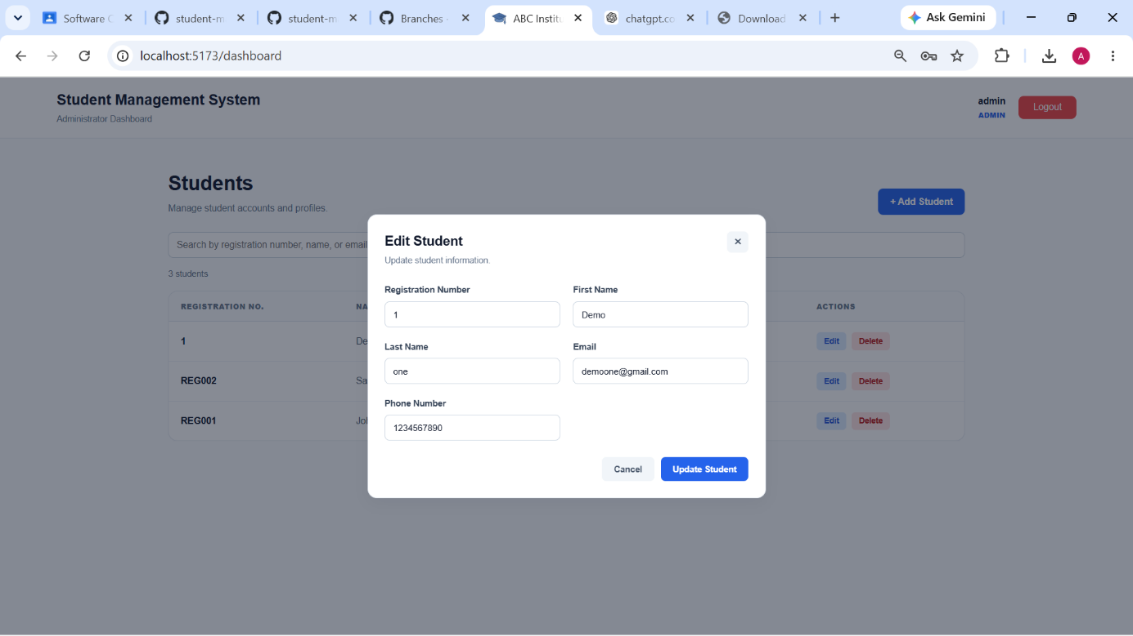
Figure 2 Successful valid student operation and/or server-side rejection of invalid student data.

Final Result

Item | Result
Change Request | CR-004
Implementation Status | Completed
Frontend Validation | Implemented
Backend Validation | Implemented
Client-side Invalid Input Prevention | Verified
Server-side Invalid Input Prevention | Verified
Password Strength Validation | Implemented
Add Student Functionality | Verified
Edit Student Functionality | Verified
Delete Student Functionality | Verified
Authentication / Authorization | Preserved
Database Schema Changes | Not Required
Overall Result | Successfully Implemented and Verified

Final Summary
CR-004 was implemented as a comprehensive student input validation enhancement for the administrator Add and Edit student operations.
Client-side validation was added to StudentFormModal.jsx to validate required student information before submission. The implementation validates registration number, first name, last name, email address, phone number, and password requirements.
First and last names are required to contain at least three characters and valid alphabetic characters. Phone numbers are required to contain exactly 10 numeric digits. Email addresses are validated for an appropriate format.
For student creation, password validation was strengthened to require a minimum of 8 characters, including an uppercase letter, lowercase letter, number, and special character.
Server-side validation was added to studentController.js to provide an additional validation and security layer. This prevents invalid data from being submitted directly to the API to bypass client-side validation.
The existing student Add, Edit, and Delete functionality was preserved. Existing authentication, authorization, database operations, and password hashing were not replaced by the change.
The implemented validation was tested using positive, negative, functional, security, UI, and regression scenarios. The tested validation requirements and existing student management functionality passed verification.

Issues / Limitations
No significant implementation issues were identified during the completed validation testing.
The change is limited to student input validation for the existing Add and Edit operations. Database schema redesign, new API endpoints, authentication changes, authorization changes, search functionality, pagination, and unrelated student management features were outside the scope of CR-004.

Student Name: M M Amal

Student ID: JF/ICT/24/15

Date: 8 October 2026

Signature: Amal

~ END OF REPORT ~

